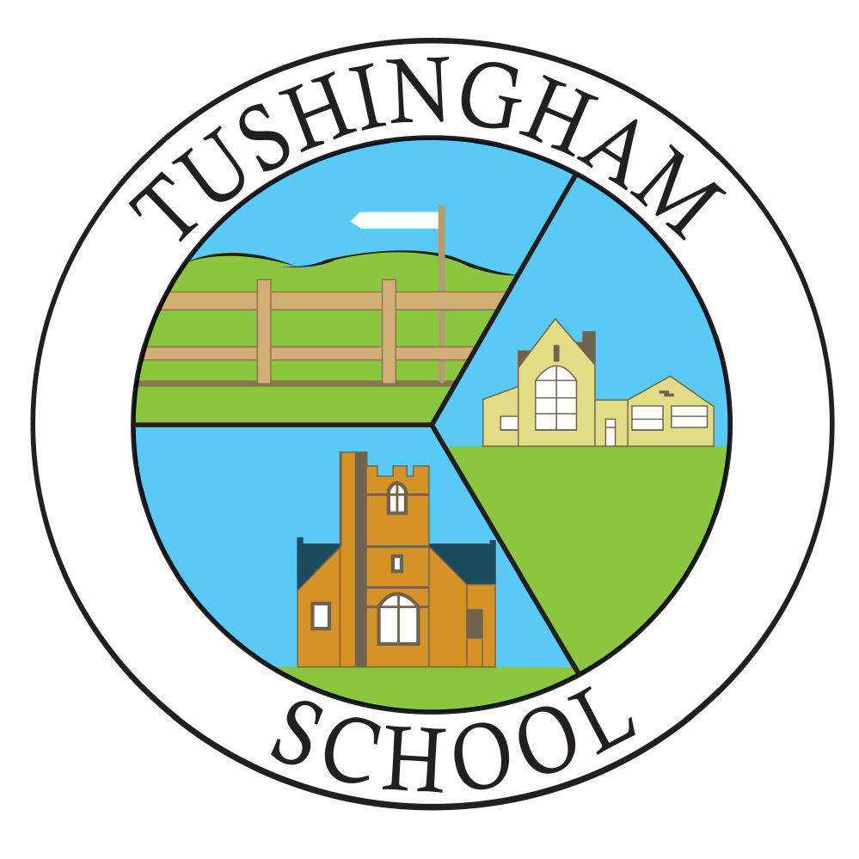
Covid-19 Risk Assessment and Recovery Plan
January 2022

Overarching Guidance for all staff:
The government continues to manage the risk of serious illness from the spread of the virus. As COVID-19 becomes a virus that we learn to live with, there is now an imperative to reduce the disruption to children and young people’s education - particularly given that the direct clinical risks to children are extremely low, and every adult has been offered the opportunity for 2 vaccines and a booster.

Our priority is to deliver face-to-face, high-quality education whilst managing risk to children, staff and families. The evidence is clear that being out of education causes significant harm to educational attainment, life chances, mental and physical health.

Department for Education guidance:
Guidance to support education and childcare providers, local authorities and parents during the COVID-19 pandemic can be accessed using the links below:
- Guidance for early years and childcare providers
- Guidance for schools
- Guidance for parents and carers

Control Measures:
- Ensure good hygiene for everyone.
- Maintain appropriate cleaning regimes.
- Keep occupied spaces well ventilated.
- Follow public health advice on testing, self-isolation and managing confirmed cases of COVID-19

Aspect | Measures to Implement | DfE Guidance | Notes | Risk
Staff | - Staff are encouraged to complete LFD tests twice weekly and before and after attending events which involve mixing with other adults.  - Staff will be encouraged to take up vaccines.  - Home working if applicable, for instance, PPA. Staff should remain on site for as long as is needed to do their job effectively. On average teachers should be in school approximately 30 minutes before the children arrive (8:15am) and are expected to stay until after school clubs finish at 4:15pm, in case the member of staff running the after- school club needs support.  - In house supply and supply teachers will be used to cover Covid staff absence where possible. Staff may be assigned to different classes and/or specific pupils and classes may need to combine.  - Social Distancing is no longer a requirement, but staff are advised to keep numbers in small spaces eg staff room to a minimum  - Staff are encouraged to use classrooms/hall/outside to meet at break times. If the hall is in use, then a classroom is a better ventilated, more spacious place to meet than the staff room.  - Staff are encouraged to keep spaces well ventilated using CO2 monitors to monitor.  - In person meetings will be restricted to essential only - meetings will be conducted via Teams/Zoom.  - SLT to monitor staff mental health. Ensure an atmosphere of openness and collaboration. | - School leaders are best placed to determine the workforce required to meet the needs of their pupils.  - Clinically extremely vulnerable (CEV) people are advised, as a minimum, to follow the same guidance as everyone else. It is important that everyone adheres to this guidance, but CEV people may wish to think particularly carefully about the additional precautions they can continue to take. Further information can be found in the guidance on protecting people who are CEV from COVID-19.  - We welcome your support in encouraging vaccine take up and enabling staff who are eligible for a vaccination to attend booked vaccine appointments where possible even during term time. |  | M
Mixing of pupils | - We will not be operating in strict classroom bubbles.  - Classes will stay together for the majority of time, but classes will be able to meet up and work together, particularly outdoors.  - Worship will take place, including singing, with classes spaced out.  - Lunches will still be eaten in separate sittings, due to space.  - During playtimes children will be able to play with those from other classes, if they wish to, outside.  - Children will continue to have separate toilets or separate toilet sessions per class.  - Visitors - including parents - are welcome into the school if necessary eg music/PE teachers. Meetings with parents are to be encouraged out of teaching time, when the school is emptier and to take place outside where possible. Face coverings are required. | - We no longer recommend that it is necessary to keep children in consistent groups (‘bubbles’). This means that bubbles will not need to be used for any summer provision (for example, summer schools) or in schools from the autumn term.  - As well as enabling flexibility in curriculum delivery, this means that assemblies can resume, and you no longer need to make alternative arrangements to avoid mixing at lunch.  - You should make sure your contingency plans (sometimes called outbreak management plans) cover the possibility that in some local areas it may become necessary to reintroduce ‘bubbles’ for a temporary period, to reduce mixing between groups.  - Any decision to recommend the reintroduction of ‘bubbles’ would not be taken lightly and would need to take account of the detrimental impact they can have on the delivery of education. |  | L
Face Coverings | - Staff must wear a face covering in communal areas eg corridor and staff room, unless exempt.  - Staff must wear a face covering when dismissing pupils or in closed or crowded spaces, unless exempt.  - Visitors must wear a face covering, unless exempt. | - Face coverings are advised for staff and visitors in communal areas.  - The government has removed the requirement to wear face coverings in law but expects and recommends that they are worn in enclosed and crowded spaces where you may come into contact with people you don’t normally meet. This includes public transport and dedicated transport to school or college.  - If you have a substantial increase in the number of positive cases in your school (see Stepping measures up and down section for more information), a director of public health might advise you that face coverings should temporarily be worn in communal areas or classrooms (by pupils staff and visitors, unless exempt). You should make sure your contingency plans cover this possibility. |  | M
Parents | - Parents will be encouraged to wear a face mask at drop off and pick up.
Visitors | - Visitors will be asked to wear a face mask and if they have done an LFD test. If not, they will be encouraged to do so in future.
Stepping  Control Measures Up | - In the event of an outbreak, the school may be advised to step measures up - see our contingency plan (outbreak management plan).  - For most education and childcare settings, an outbreak is whichever of these thresholds is reached first:  • 5 children, pupils, students or staff, who are likely to have mixed closely, test positive for COVID-19 within a 10-day period; or  • 10% of children, pupils, students or staff who are likely to have mixed closely test positive for COVID-19 within a 10-day period | You should have contingency plans (sometimes called outbreak management plans) outlining what you would do if children, pupils, students or staff test positive for COVID-19, or how you would operate if you were advised to take extra measures to help break chains of transmission. Given the detrimental impact that restrictions on education can have on children and young people, any measures in schools should only ever be considered as a last resort, kept to the minimum number of schools or groups possible, and for the shortest amount of time possible.  Central government may offer local areas of particular concern an enhanced response package to help limit increases in transmission.  For most settings it will make sense to think about taking extra action if the number of positive cases substantially increases. Information on what circumstances might lead you to consider taking additional action, and the steps you should work through, can be found in the contingency framework.  The contingency framework describes the principles of managing local outbreaks of COVID-19 in education and childcare settings. Local authorities, directors of public health (DsPH) and PHE health protection teams (HPTs) can recommend measures described in the contingency framework in individual education and childcare settings – or a small cluster of settings – as part of their outbreak management responsibilities. |  | M
Actions

Aspect | Measures to Implement | DfE Guidance | Notes | Risk
Ensure good hygiene for everyone | Children will continue to hand wash or use sanitiser at regular and frequent points throughout the day particularly when entering and exiting the classroom and before and after eating.  At the end of break time and lunch time, TA or teacher to clean touch points in toilets: taps, handles, flush.  Paper towels to be provided to reduce use of hand dryer.  Drinking fountain to remain closed off.  Tissues and pedal bins are readily available in each classroom to maintain the ‘catch it, bin it, kill it’ approach. | - Hand hygiene  Frequent and thorough hand cleaning should now be regular practice. You should continue to ensure that pupils clean their hands regularly. This can be done with soap and water or hand sanitiser.  - Respiratory hygiene  The ‘catch it, bin it, kill it’ approach continues to be very important.  The e-Bug COVID-19 website contains free resources for you, including materials to encourage good hand and respiratory hygiene.  - Use of personal protective equipment (PPE)  Most staff in schools will not require PPE beyond what they would normally need for their work. The guidance on the use of PPE in education, childcare and children’s social care settings provides more information on the use of PPE for COVID-19. |  | M
Maintain appropriate cleaning regimes, using standard products such as detergents | Extra cleaning is to remain in place.  Classroom staff will wipe down tables and touched surfaces and equipment regularly. | - You should put in place and maintain an appropriate cleaning schedule. This should include regular cleaning of areas and equipment (for example, twice per day), with a particular focus on frequently touched surfaces.  - PHE has published guidance on the cleaning of non-healthcare settings. |  | M
Keep occupied spaces well ventilated | Classroom doors, both internal and external should be open, where possible. Windows should be opened to maintain good ventilation.  Windows on corridors should be opened where possible.  Where temperatures drop in the autumn/winter, periods of ventilation should be carried out for at least 5 minutes per hour or where the CO2 levels increase. | - When your school is in operation, it is important to ensure it is well ventilated and that a comfortable teaching environment is maintained.  - You should identify any poorly ventilated spaces as part of your risk assessment and take steps to improve fresh air flow in these areas, giving particular consideration when holding events where visitors such as parents are on site, for example, school plays.  - Mechanical ventilation is a system that uses a fan to draw fresh air or extract air from a room. These should be adjusted to increase the ventilation rate wherever possible and checked to confirm that normal operation meets current guidance and that only fresh outside air is circulated.  - If possible, systems should be adjusted to full fresh air or, if this is not possible, then systems should be operated as normal as long as they are within a single room and supplemented by an outdoor air supply.  - Where mechanical ventilation systems exist, you should ensure that they are maintained in accordance with the manufacturers’ recommendations.  - Opening external windows can improve natural ventilation, and in addition, opening internal doors can also assist with creating a throughput of air. If necessary, external opening doors may also be used (if they are not fire doors and where safe to do so).  - You should balance the need for increased ventilation while maintaining a comfortable temperature.  - The Health and Safety Executive guidance on air conditioning and ventilation during the COVID-19 pandemic and CIBSE COVID-19 advice provides more information.  - DfE is working with Public Health England, NHS Test and Trace, and the Scientific Advisory Group for Emergencies (SAGE) on a pilot project to measure CO2 levels in classrooms and exploring options to help improve ventilation in settings where needed. |  | M
Follow public health advice on testing, self-isolation and managing confirmed cases of COVID-19 | Staff will continue to observe children and to inform senior leaders if they identify a child or adult with symptoms.  A child will be isolated (outside where possible or in the EHT office) and parents will be contacted to take the child home. They will be advised to take a PCR test.  Children may return to school once symptoms have ceased or a negative test result is returned.  The staff member monitoring the child once isolated should wear a face covering.  For any staff member or child isolating after a positive PCR test, on day 6 and day 7 of the self-isolation period, 2 LFD tests can be taken (24 hours apart). Those who receive two negative test results and do not have a high temperature can end their self-isolation and return to school. Alternatively, the full 10 full days of self-isolation should be completed. This also applies to children under 5.  Close contacts of a person with confirmed positive for Covid, should take an LFD test every day for seven days and continue to attend school as normal, unless they develop symptoms at any time. | - When an individual develops COVID-19 symptoms or has a positive test  - Pupils, staff and other adults should follow public health advice on when to self-isolate and what to do. They should not come into school if they have symptoms, have had a positive test result or other reasons requiring them to stay at home due to the risk of them passing on COVID-19 (for example, they are required to quarantine).  - If anyone in your school develops COVID-19 symptoms, however mild, you should send them home and they should follow public health advice.  - If a pupil is awaiting collection, they should be left in a room on their own if possible and safe to do so. A window should be opened for fresh air ventilation if possible. Appropriate PPE should also be used if close contact is necessary. Further information on this can be found in the use of PPE in education, childcare and children’s social care settings guidance. Any rooms they use should be cleaned after they have left.  - The household (including any siblings) should follow the PHE stay at home guidance for households with possible or confirmed coronavirus (COVID-19) infection.  - Children under 5 are not being advised to take part in daily testing of close contacts. If a child under 5 is a contact of a confirmed case, they are not required to self-isolate and should not start daily testing. If they live in the same household as someone with COVID-19 they should limit their contact with anyone who is at higher risk of severe illness if infected with COVID-19, and arrange to take a PCR test as soon as possible. They can continue to attend an education or childcare setting while waiting for the PCR result. |  | M
Actions
Remote Education | - Remote education will be provided to pupils where their attendance would be contrary to government guidance or legislation around COVID-19.  - See remote education plan.  http://www.shocklachoviatt.cheshire.sch.uk /resources/__e6c54501032edbbce7b9bd8202ffdfd9.pdf | Where we have to provide remote/blended learning, there are case studies on developing and adopting flexible learning approaches The government are saying live streaming is the preferred method for providing this wherever possible. There should be regular feedback and checking in with students and pupils. You can also access bespoke one-to-one support from the EdTech Demonstrator network  - Not all people with COVID-19 have symptoms. Where appropriate, you should support those who need to self-isolate because they have tested positive to work or learn from home if they are well enough to do so. Schools subject to the remote education temporary continuity direction are required to provide remote education to pupils covered by the direction where their attendance would be contrary to government guidance or legislation around COVID-19.  - You should maintain your capacity to deliver high-quality remote education for the next academic year, including for pupils who are abroad, and facing challenges to return due to COVID-19 travel restrictions, for the period they are abroad.  - Independent Schools (not including academies) are only covered by the remote education temporary continuity direction in relation to state-funded pupils in their schools. However, they are still expected to meet the Independent School Standards in full at all times.  - The remote education provided should be equivalent in length to the core teaching pupils would receive in school.  - You should work collaboratively with families and put in place reasonable adjustments so that pupils with special educational needs and disabilities (SEND) can successfully access remote education.  - Full expectations for remote education, support and resources can be found on the get help with remote education service. |  | L
Actions

Teaching, Learning and Curriculum | Class teachers will be responsible for planning of a broad and ambitious curriculum. All subject areas will be covered. A focus remains on mental health and wellbeing.  It is essential that a full curriculum is delivered with a focus on quality first teaching. ‘Catch up’ or ‘recovery’ has been identified as a long-term issue and that highly skilled teachers will be best placed to enable this to happen.  - Focus on Mental Health and Well-Being. Utilise specific Catch-up planning from the Literacy Company and DfE Maths Guidance.  - Develop a programme for specific children in order to address any gaps in learning from being away from school.  - PE – children to come to school in PE kit if they are to have it that day, in order to minimise changing etc.  - Forest School to continue but now in 3 separate groups– children attend in outdoor clothing as per previous arrangements. | - We have announced a number of programmes and activities to support pupils to make up education missed as a result of the pandemic. Further information is available on education recovery support. Specifically for schools, the document includes further information on:  - catch-up premium  - recovery premium  - summer school programme  - tutoring (including the National Tutoring Programme and 16 to 19 tuition fund)  - teacher training opportunities  - curriculum resources  - specialist settings  - wider continuous professional development resources, including to support teacher wellbeing and subject-specific teaching  - If running a summer school, you should follow the protective measures for holiday and after-school clubs, and other out-of-school settings during the coronavirus (COVID-19) outbreak.  - Special schools and other specialist settings should refer to the additional operational guidance. | Expectations on staff feedback should be majority class-based with little need to take books/marking home. | L
First Aid | - PPE should be worn (gloves and face covering) when dealing with a first aid incident. |  |  | H
Actions

Educational VIsits | - Educational visits may take place and must be risk assessed using Evolve in the usual way.  - Visits must clearly be linked to educational opportunities and add significantly to the curriculum. | - Given the likely gap in COVID-19 related cancellation insurance, if you are considering booking a new visit, whether domestic or international, you are advised to ensure that any new bookings have adequate financial protection in place.  - You should speak to either your visit provider, commercial insurance company, or the risk protection arrangement (RPA) to assess the protection available. Independent advice on insurance cover and options can be sought from the British Insurance Brokers’ Association (BIBA) or Association of British Insurers (ABI). Any school holding ATOL or ABTA refund credit notes may use these credit notes to rebook educational or international visits.  - You should undertake full and thorough risk assessments in relation to all educational visits and ensure that any public health advice, such as hygiene and ventilation requirements, is included as part of that risk assessment. General guidance about educational visits is available and is supported by specialist advice from the Outdoor Education Advisory Panel (OEAP). |  | L
Shielding and clinically vulnerable children and adults. | - Sheilding is currently paused and all children and adults are expected to be in school.  - Any member of staff or parent with concerns should contact the school to discuss possible options and seek advice. | - All clinically extremely vulnerable (CEV) children and young people should attend their education setting unless they are one of the very small number of children and young people under paediatric or other specialist care who have been advised by their clinician or other specialist not to attend.  - Further information is available in the guidance on supporting pupils at school with medical conditions.  - Clinically extremely vulnerable (CEV) people are advised, as a minimum, to follow the same guidance as everyone else. It is important that everyone adheres to this guidance, but CEV people may wish to think particularly carefully about the additional precautions they can continue to take. Further information can be found in the guidance on protecting people who are CEV from COVID-19.  A course of vaccination will be offered to children aged 5 to 11 years old who are in a clinical risk group, or who are a household contact of someone (of any age) who is immunosuppressed. |  | M

