Collective Worship POLICY

Tushingham with Grindley CE Primary School
Tushingham, Whitchurch, Cheshire. SY13 4QS

1 John 4:7 Let us love one another, for love is from God
Learning together and worshipping together
___________________________________________________________________

Date: December 2023

Review date: December 2024

Signed by:

Executive Head Teacher: C Davies

Chair of Governors: J Davies

Vision and Aims of Collective Worship
Let us love one another for love is from God. 1John 4:7
Learning together and Worshipping together.
Daily collective worship is an integral part of school life at Tushingham and thus is included in our vision for all pupils: ‘Learning Together and Worshipping Together.‘ It provides pupils with an opportunity for spiritual development ; an opportunity to inwardly explore and develop their own faith or world view and outwardly consider how they can impact the world.
Encouraged by a supportive family ethos, our Christian worship, teaches of God’s, unconditional never-ending love to us and thus we encourage through our worship how we must pass on that love to one another. Our Christian ethos and curriculum are interwoven so as to teach our children empathy and compassion for others, alongside knowledge, thoughts, actions and attitudes for themselves, so that they are guided to make a positive impact in the world, both now and in the future.

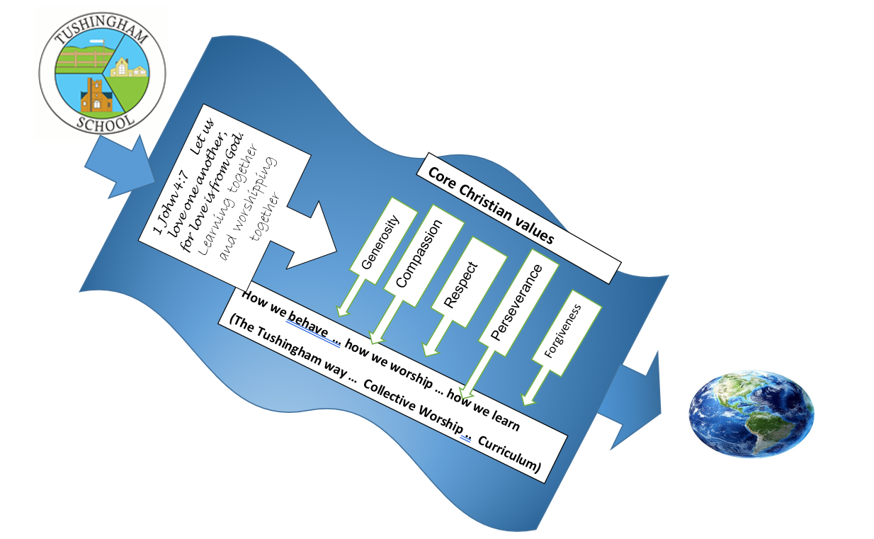

Core Christian Values
We have chosen 5 Core Christian values for our school that link to our Vision. These values are explored throughout the year in our Collective worship time, so as to enable and encourage the children to live out our values in their lives.
Aut 1 – Generosity Aut 2 - Compassion
Sp 1 - Respect Sp 2 - Forgiveness
Summer – Perseverance
We have elected class Vivas ( Vision Influences and Value Advocates) who with staff promote the living out of these values. They also assist in leading Monday worship and proudly wear their VIVA badges in school.
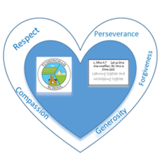

Daily Worship
We structure our worship following the Church of England Guidance ensuring that it is inclusive, invitational and inspirational. Throughout the week teachers and SLT take turns to lead the worship. Each day has a different focus, so as to aid the deep spiritual development of all pupils.
Day | Teacher | Focus
Monday Whole School | Class teacher /VIVAS | Inspirational People / National events and theme weeks
Tuesday Whole School | Class teacher | Half termly Value
Wednesday KS worship | Class teacher | Bible Stories
Thursday | Christian church leader / SLT | Half termly Value
Friday | SLT | Celebration worship with Parents

Each worship follows the same structure and liturgy, therefore enabling pupils to comfortably participate and lead, as they feel able to do so:
- Welcome : open by lighting the 3 candles and saying welcome words
- ‘We have gathered together in the name of God the father, God the son and God the Holy spirit to worship together and think about our value of ……………………………. ‘
- Learning : Bible story /other story related to focus
- Reflect /respond – how will their learning from worship impact the children
- End with Song & prayer – School prayer/ Lord’s Prayer / child or adult own prayer
- 2 Children fill in reflection sheet
We use sacred texts, stories, poems, music, artwork and drama to create interactive learning within our worship, on which the pupils are given opportunities to reflect before they respond by considering how the worship might lead them to change the way they live their lives. After each Collective worship, all children are encouraged to reflect on our vision statement and 2 volunteers record these reflections in our written record.

Reflection and Prayer opportunities.
In the hall, a prayer tree, stained glass window and cross form the focus for our whole class worship, but each class space has reflection areas to aid in class worship and reflection times. We use 3 candles in each worship to provide a central point of focus which we light during our opening prayer. We include daily prayers in the classroom routine and encourage spontaneous or unplanned moments of reflection wherever appropriate. We have interactive prayer activities in the hall and playground which the pupils are invited to use independently.

Community Links and opportunities for Worship
There is a strong link between our school St Chad’s Church in Tushingham which has been long established since the creation of the school over 100 years ago. The whole school attends services at St Chad’s each term bringing together the school and church communities, with parents invited to attend each occasion. A weekly worship, in school, is led by a member of clergy from a local church but the school also promotes the weekly church services at St Chads’, especially during the festivals of Harvest, Easter and Christmas. In this way the pupils are able to experience Christian worship in the wider Christian community.

Other Faiths
Although our worship reflects our Christian beliefs and values, we are committed to respecting each other’s world views, showing tolerance and understanding regardless of individual pupils’ beliefs.

Equal Opportunities and special needs issues
All pupils, regardless of academic ability, age, gender and ethnic origin will have access to a wide range of appropriate activities to support their understanding of R.E. At each Key Stage, the teacher will draw from other religions, as appropriate, to acknowledge and celebrate the religious beliefs of the children within the class.

Legal Requirements
We acknowledge the legal requirement stated in the 1988 Education Reform Act 6 (1) and 9 (3), which states the need for each child to attend a daily act of worship either as a whole school, class or group. Parents have the legal right to withdraw their children from the act of worship either partially or wholly. Any parents wishing to do so should contact the Headteacher. Teachers also have the right to withdraw from leading and taking part in worship.

